breez75X

Table Of Contents
breez75X Introduction 1
QA 5
Emissions 11
Editing Data 16

breez75X Introduction

Before running breez75X software, the following directories must be set up correctly.

A local drive on your computer should contain a folder labeled breez75X (For example, C:\breez75X). The breez75X folder should contain a subfolder for each 40CFR75 unit at your site.

Each Unit folder should contain a folder named Official Data. This folder should store the final quarterly emissions XML file that was submitted and accepted by the EPA. There must be one and only one emissions file in this folder for each previous quarter dating back to the certification date.

The Unit folder should also contain a Work subfolder for each quarter, named with the year and quarter (For example, C:\breez75X\Unit 1\Work 2008Q1). Each Work folder will contain the following subfolders:

- Candidate Files
- ECMPS Results
- Logs

Each time you create a QA or Emissions file using breez75X, the file is put in the Candidate Files subfolder under the Work folder for the appropriate year and quarter.

The ECMPS Results folder is a place for you to store Evaluation and Feedback Reports from the ECMPS Client Tool.

There is also a folder called Logs under each Work folder. Each time you generate a QA or Emissions file using breez75X, a log file is created and placed in the Logs folder. These log files are used for troubleshooting purposes in the event that a QA or Emissions file is not successfully created.

The following illustrates how the folders should be set up on your local drive.

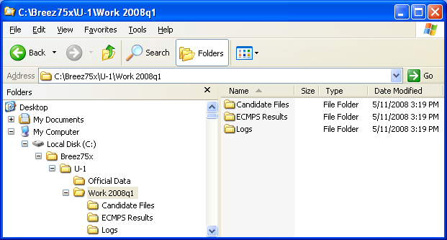

To open the breez75X software, click on the icon on your desktop or click Start > All Programs > breez75X by CiSCO.

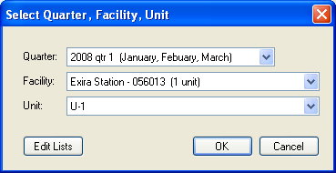

A select window opens. Use the pull-down menus to select a Quarter, Facility and Unit.

Click [OK].

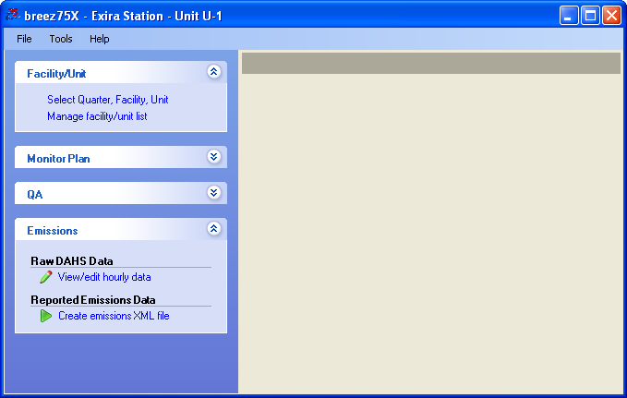

Use the items on the task panel to make a selection. The following options appear on the task panel.

- Facility/Unit
- Monitor Plan
- QA
- Emissions

We will discuss these options individually.

QA

To view, edit, or evaluate a linearity check click Linearity Check under the QA option on the task panel.

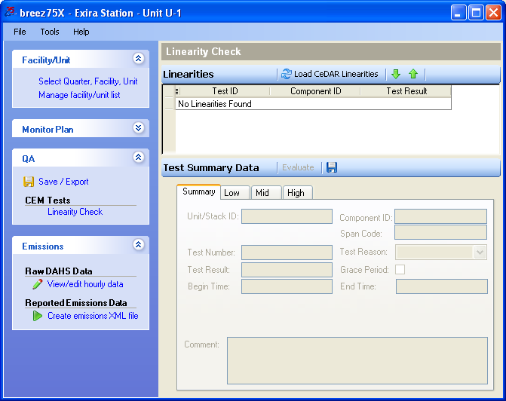

The main linearity window is displayed.

Click [Load CeDAR Linearities].

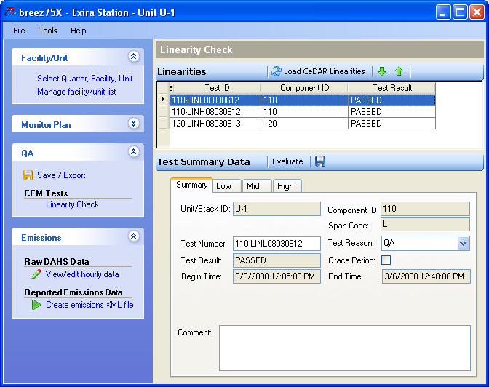

The linearities for the selected quarter and unit appear in the top portion of the window. Use to skip to the next linearity. Use to skip to the previous linearity. Or highlight the linearity that you wish to view, edit, or evaluate. The data for the linearity is displayed in the bottom portion of the window.

To edit linearity data, click in an open field and type in a new value or use the pull-down menus. Click to save the changes.

You should evaluate a linearity after you have edited it or before you export a linearity check into an XML file. To evaluate a linearity, click [Evaluate].

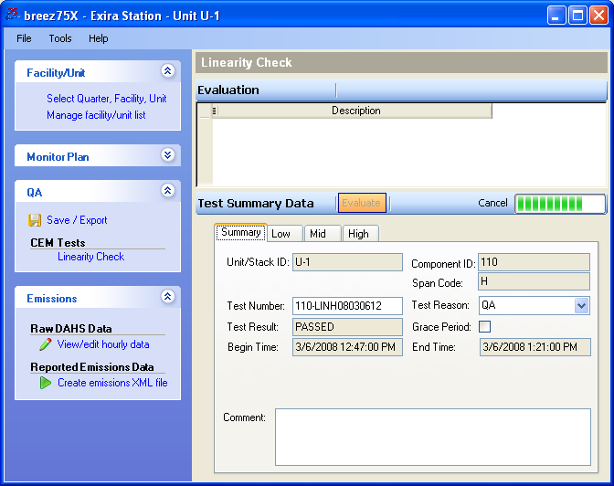

breez75X begins an evaluation of the linearity that you selected. Click [Cancel] to end the evaluation.

When the software has finished the evaluation, the results are displayed in the top portion of the window.

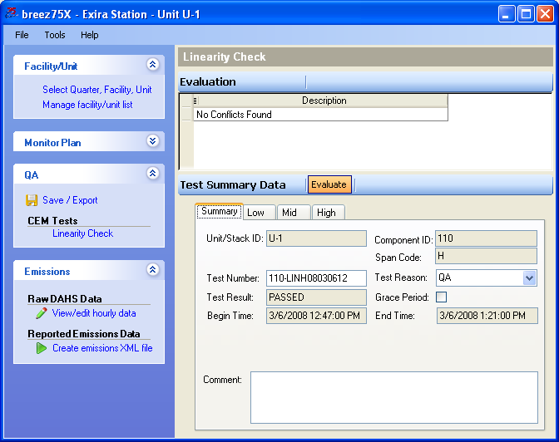

To create an XML file for a linearity, click Save / Export.

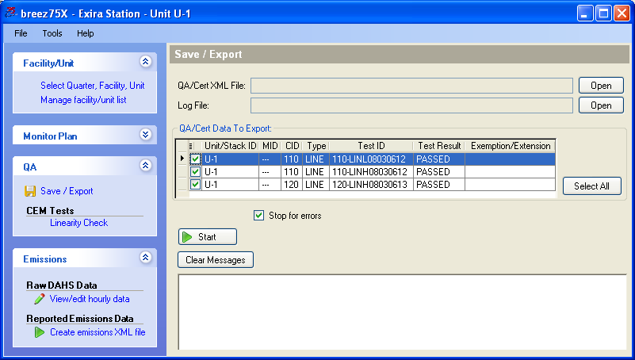

Select the linearities that you wish to export.

Click [Start].

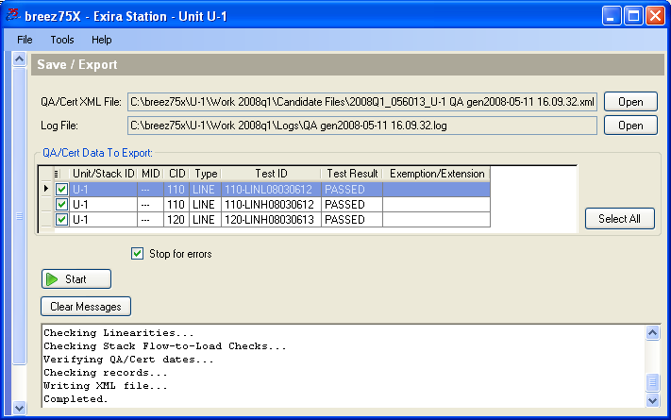

The linearity XML file is placed in the Candidate Data folder in the appropriate Work folder. The file is named with the year and quarter, the facility ORIS code, unit name, QA (indicating that this is QA data), and the date and time the file was generated.

Emissions

Emissions allows you to view and edit hourly data and create quarterly emissions files in XML format.

You should check your hourly data and resolve any data conflicts before creating your quarterly emission file. To check or edit hourly data, click View/Edit hourly data.

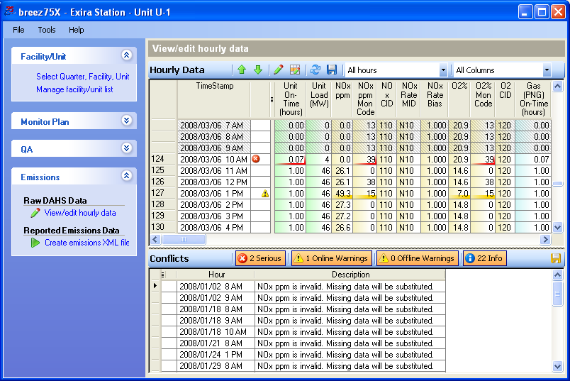

Each hour in the quarter is listed in the top portion of the window. Each online hour has a line number to the left. Offline hours are shaded gray.

Data with serious errors are highlighted in red. These conflicts should be resolved before submitting the data to the EPA. Data highlighted in yellow indicates a warning. These are potential data issues that may need to be resolved.

If you place your cursor over a field where there is a serious error or a warning, pop up text appears explaining the error.

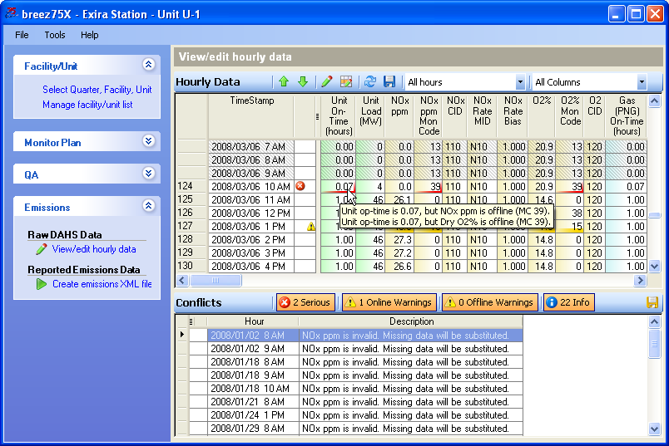

Use to skip to the previous conflict. Use to skip to the next conflict.

Use the pull down menu to select the hours you would like to view. You can choose from the following:

- All hours
- Conflict hours only
- Conflict hours + 4 hours
- Conflict hours + 12 hours
- Online hours only

Some columns may contain data that does not change for the entire quarter. Use the pull down menu to select Hide Constant Columns to remove these columns from view. This reduces the amount of data you have to examine.

Note: Constant values cannot be edited using breez75X. If you need to edit these values, use the CeDAR Data Monitor Settings or Database Editor Settings to change these values. If you try to edit them using breez75X, you may see the following message.

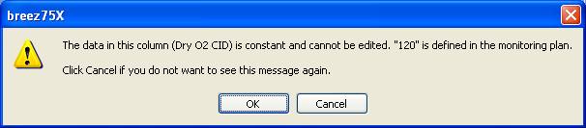

The bottom portion of the window displays the number of Serious errors, Online Warnings, Offline, and Informational conflicts for the quarter. Click on the tab heading to show or hide these conflicts in the list below. Clicking on a conflict in the list causes that hour to be selected and displayed.

Click in the Conflicts title bar to save a list of conflicts.

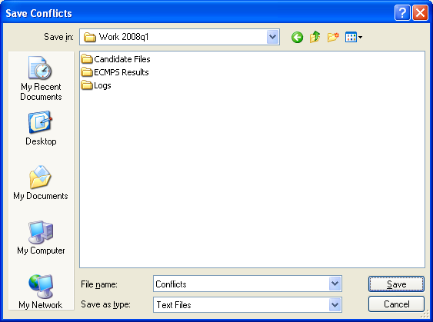

A Save window opens. Select a location to save the file and name it. Click [Save].

The following is an example of a conflict list.

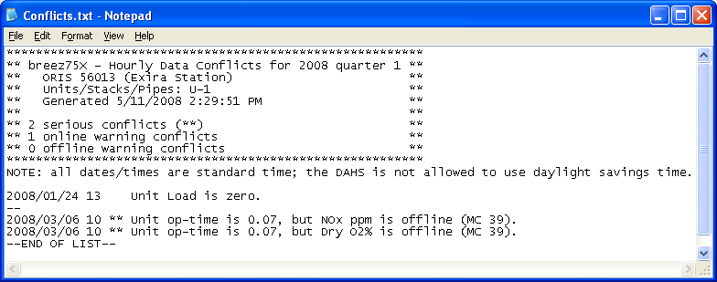

Editing Data

breez75X provides several ways to edit data. You can edit a single data value by double clicking in the field and typing in the new value.

Note: Not all values displayed in breez75 can be edited, such as constants and calculated values. For calculated values, you can usually edit the underlying raw data but will need to refresh the conflicts list before you will see these changes

To edit a single hour using breez75X, highlight the hour and click . You can select multiple hours by using the Ctrl key or select a block of hours by using the Shift key.

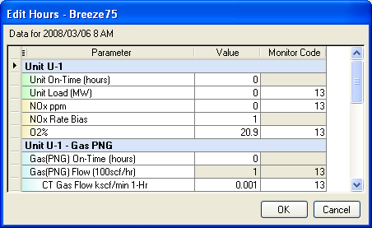

To change a value, click in the field and type in the new value accordingly. Fields that appear in gray are for informational purposes and cannot be changed.

To change a monitor code, double click on the field.

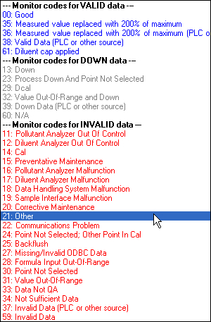

You receive a pop up window with a list of monitor codes. Monitor codes are categorized by VALID, DOWN, and INVALID data. Scroll down to select the appropriate monitor code.

When you have finished editing, click [OK].

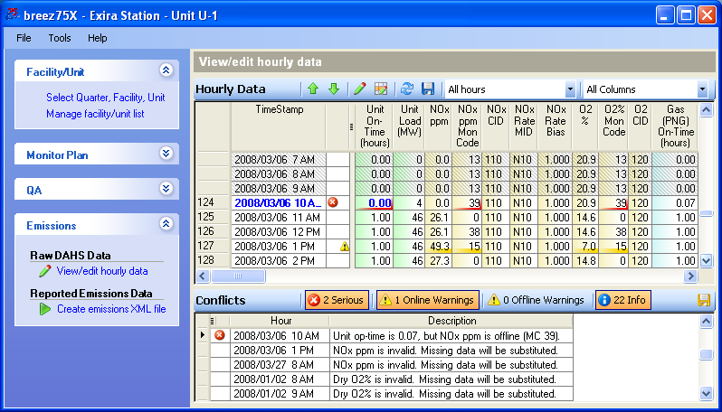

The date and time and the values that have been edited appear in blue.

Another editing technique can be used when you would like to mark an entire hour or group of hours to offline. To edit an hour or group of hours offline, select the hour (s) and click .

You receive a pop up window that allows you to confirm that these are the hours you wish to set offline.

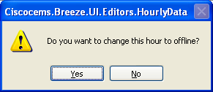

Click [Yes].

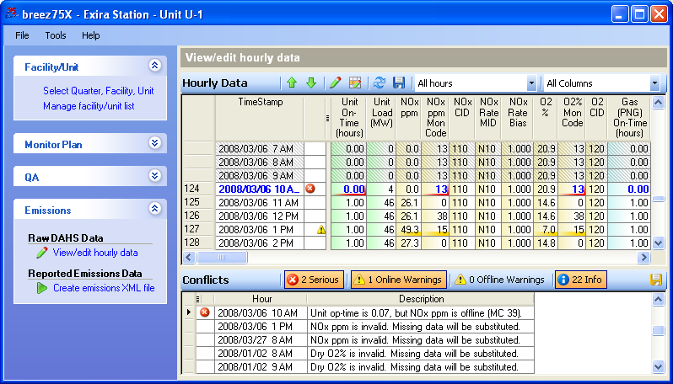

The date and time and the values that have been edited appear in blue. The monitor codes for the selected hours are changed to 13 and the operating times for the selected hours are changed to 0.00.

Click to save the changes.

Click to check the conflicts again.

To create a quarterly emissions file, click Create emissions XML file.

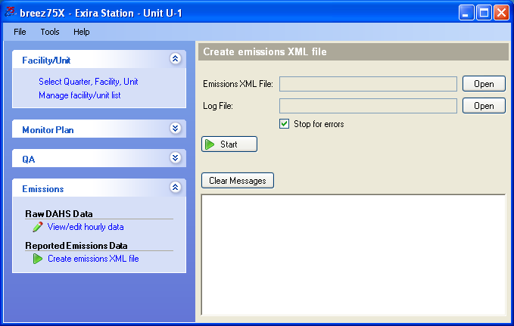

Click [Start].

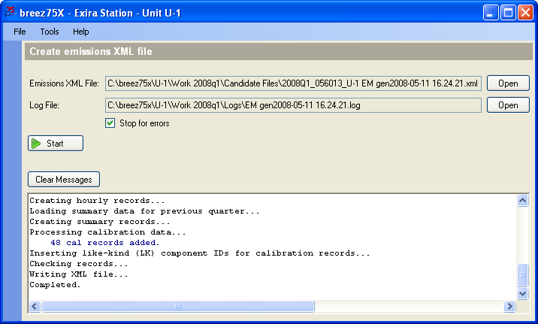

The emissions XML file is placed in the Candidate Data folder in the appropriate Work folder. The file is named with the year and quarter, the facility ORIS code, unit name, EM (indicating that this is emissions data), and the date and time the file was generated.

