9970 Carroll Canyon Rd, San Diego, CA, 92131-1106

Phone (858) 657-9800 Fax: (858) 657-9818 Toll Free 1800 324-5190

E-mail: [sda_techsupport@teledyne.com](mailto:sda_techsupport@teledyne.com) Website: <http://www.teledyne-api.com>

**22-003**

**26 April, 2022**

###### Tubing and Flowmeter Replacement

###### for the 480H

1. **Purpose:**

To provide guidance on replacing the tubing and flowmeter as needed, on a 480H.

1. **TOOLS:**

#1 Phillips Screwdriver

#2 Phillips Screwdriver

9/16” Wrench

5/8” ‘Backing’ Wrench

Pick or scribe

¼” Cap for leak checking purposes

External gas flowmeter (measures at least 2.0 LPM)

1. **PARTS:**

KIT000394, Flowmeter & Tubing Kit, 480H

1. **PROCEDURE:**



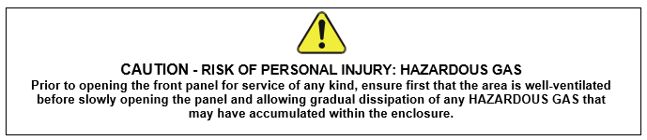

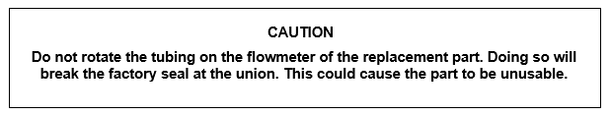

1. Remove power from the instrument.
2. Open the 480H NEMA box to access the analyzer internals.
   1. If the instrument has a relay board installed, as shown below – you will need to remove the board to access the tubing and flowmeter accordingly. For this process, review the following steps.

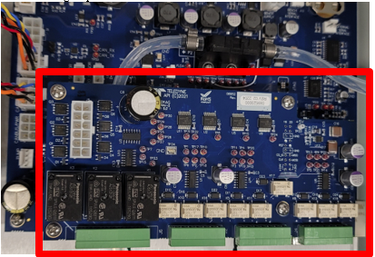

* + 1. For removing the relay board, note the position of the four screws securing the relay board to the mainboard, as shown below, and remove any connections that may be installed on the board at this time.

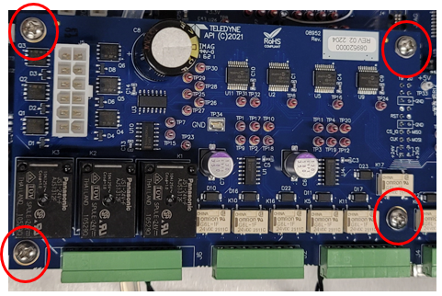

* + 1. Use the #2 Phillips screwdriver to remove the four (4) screws at each corner of the board.
    2. After the four (4) screws have been removed, remove the relay board – please use caution when lifting and releasing the relay board from the mainboard connector.

**For this next step, please do not remove the tubing from the flowmeter, as this will be removed as a whole unit. **

1. Once the relay board is removed, or if the unit does not have a relay board installed – begin removing the two (2) screws on the flowmeter using the #1 Phillips screwdriver and take note of the two nylon spacers that will be placed between the mainboard and the bottom of the flowmeter. Please retain the screws and spacers for the replacement flowmeter.

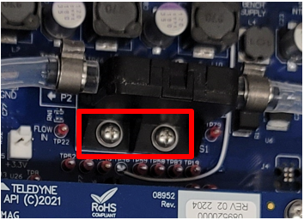

1. Loosen the tubing nut at the outlet port of the exhaust scrubber (shown below) by using the 9/16” wrench on the tubing nut and the 5/8” ‘backing’ wrench to hold the bulkhead fitting.

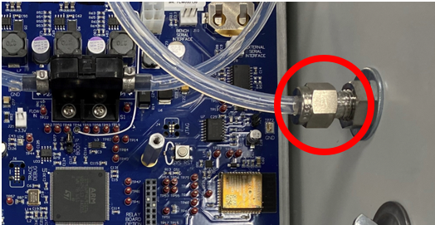

1. Next, loosen the tubing nut from the exhaust port of the analyzer (shown below) by using the same method and wrenches previously listed in step 4.

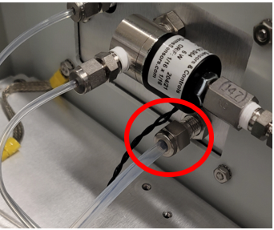

1. After the tubing has been loosened at both ports, remove the tubing and flowmeter as a whole and set aside.
2. Carefully remove the new flowmeter and tubing (KIT000394) from its packaging.
3. Carefully place flowmeter assembly into the instrument and align the three (3) pins on the bottom of the flowmeter with the appropriate sockets on the mainboard. At this time, please place the nylon spacers underneath the flowmeter as you place it into position on the mainboard (a scribe or pick can be used to assist in the alignment of these spacers).
4. Using the #1 Phillips screwdriver, reinstall the screws securing the flowmeter to the mainboard but do not fully tighten. Having the flowmeter move a little will help position the tubing.
5. Next, connect the new tubing to each of the bulkhead fittings using caution, as not to rotate the tubing on the flowmeter.
   1. Using the 9/16” wrench on the tubing nut and the 5/8” ‘backing’ wrench to hold the bulkhead fitting, tight the tubing nut (1/8 of a turn past finger tight).
6. Once the tubing has been tightened, return to the flowmeter, and tighten the screws securing the flowmeter to the mainboard, until snug.
7. If the instrument has a relay board, please see the following steps. If the instrument does not have a relay board, proceed to step 13.
   1. Carefully align the pins from the relay board with the connector on the mainboard.
   2. Once aligned, press down firmly to seat the pins.
   3. With the relay board properly seated, install the four (4) screws using the #2 Phillips screwdriver and reattach any connectors.
8. With everything re-connected, see following steps for performing a leak check.
   1. Run approx. 15PSI oxygen or nitrogen through the analyzer, cap the outlet of the analyzer, and hold this pressure (pressurize the instrument at 25-30PSIA, as shown on instrument display – access pressure reading by going to SENSOR🡪PRESS) for approx. 5 minutes.

**\*Note that the instrument will produce a ‘pneumatic error’ which is to be expected during this test. \***

* 1. After the 5 minutes is complete, if the pressure has dropped more than 1psi, then the instrument has failed the leak check and could potentially have a leak (see step ‘c’ below). If the instrument held pressure appropriately, please proceed to step 14, and remove the cap from the exhaust port, returning the instrument back to ambient pressure.
  2. If it fails the leak check as stated above, please re-check fittings for any leaks and run through the leak check steps again.

**\*Note that the instrument is only considered to be within spec and safe for operation if it is considered ‘leak-free’ and has passed the leak check appropriately. \***

* 1. If you feel that assistance is needed for this step, please contact Teledyne API Technical Support.

*Once the instrument has passed the leak check appropriately, please proceed with the following steps. *

1. Connect the instrument to a power source and allow the instrument to boot.
2. With the new flowmeter installed, calibration of the flowmeter can be done by connecting an external flowmeter to the exhaust port of the instrument (see diagram below).
3. Connect oxygen or nitrogen to the sample port.
4. Navigate to the Flow Calibration Menu by going to DIAG 🡪 CAL 🡪 FLOW CAL.
5. Enter the flow reading, displayed by the external flowmeter, into the display field on the instrument, and press ‘Execute Flow Cal’.
6. Now the displayed flow on the main screen of the instrument should closely match the readings on your external flowmeter. If for any reason it does not, or should you require assistance, please reach out to Teledyne API Technical Support.
7. Once these steps are complete, the instrument is ready to be placed back into service.