9970 Carroll Canyon Rd, San Diego, CA, 92131

### Service Note

Phone (858) 657-9800 Fax: (858) 657-9818 Toll Free 1800 324-5190

E-mail: [sda\_techsupport@teledyne.com](mailto:sda_techsupport@teledyne.com) Website: <http://www.teledyne-api.com>

***22-002***

***18 April, 2022***

###### REST API Tutorial For numaview instruments

1. **Purpose:**

To provide examples of how the REST protocol can be used to collect data, change parameters, extract data logs, poll groups of parameter values, and trigger calibration functions.

1. **TOOLS:**

For GET commands, any web browser

For PUT commands, postman ([www.postman.com](http://www.postman.com)) or other API platform

1. **PARTS:**

Computer with internet access and Numaview instrument both connected on the same network

1. **REST GET COMMANDs:**

**GET commands are commands used to read or “get” a value. These can be utilized using just a web browser and does not make any changes to the instrument. Note that most modern web browsers will download the response as a file with no file extension whereas older web browsers such as internet explorer will display the response within the browser. The file without an extension can have .txt added to the end in order to view the response in a text document.**

1. **TAGS**

Tags are any parameter within the instrument that is used or measured. In the example below, we will use a concentration tag. **Note that tag names and command strings are case sensitive**

Using a web browser, we can view full details of the tag using the below command example:

<http://10.20.22.10:8180/api/tag/CO_CONC>

**The response will be as shown below:**

{"name":"CO\_CONC","type":"float","value":"0.145923003554344","properties":"{\"Precision\":3,\"RawMin\":0.0,\"RawMax\":500000.0,\"EuMin\":-1000.0,\"EuMax\":200000.0,\"EuTag\":\"SV\_USER\_UNITS\",\"Default\":0.0,\"Name\":\"CO\_CONC\",\"HmiLabel\":\"CO Concentration\",\"Description\":\"CO Concentration in PPM\",\"Group\":\"PRIGAS,LOG,TRIG,AOUTMAP,HIST,TRACK\_ALL\_UPDATES\",\"Units\":\"PPM\",\"IsValueValid\":true,\"IsReadOnly\":true,\"IsNetwork\":true,\"IsVisible\":true,\"IsNonVolatile\":false,\"IsDashboard\":false,\"CanDashboard\":true}"}

Here is a breakdown of the response string where commas separate each line. We won’t go over every line in this tutorial but will cover some key ones:

"name":"CO\_CONC" **This is the name of the tag**

"type":"float" **This is how the value is viewed; float refers to floating point which is a type of number where the decimal is not in a fixed position**

"value":"0.145923003554344" **This is the current value of the tag**

"properties":"{\"Precision\":3 **This refers to the number of places after the decimal that the value is viewed on the instrument display**

\"RawMin\":0.0

\"RawMax\":500000.0

\"EuMin\":-1000.0

\"EuMax\":200000.0

\"EuTag\":\"SV\_USER\_UNITS\"

\"Default\":0.0

\"Name\":\"CO\_CONC\"

\"HmiLabel\":\"CO Concentration\"

\"Description\":\"CO Concentration in PPM\"

\"Group\":\"PRIGAS,LOG,TRIG,AOUTMAP,HIST,TRACK\_ALL\_UPDATES\" **This tells us which groups of tags that the tag we’re viewing reports in. We’ll discuss groups further in the tutorial.**

\"Units\":\"PPM\"

\"IsValueValid\":true

\"IsReadOnly\":true **This tells us if this is a tag that we can change with a PUT command, or if it can only be changed by the software**

\"IsNetwork\":true

\"IsVisible\":true

\"IsNonVolatile\":false

\"IsDashboard\":false

\"CanDashboard\":true}"}

1. **TAG VALUES**

When we know a tag name, and only want to get the value of the tag, we can use the below command which will generate the subsequent response:

<http://10.20.22.10:8180/api/tag/CO_CONC/value>

Response:

{"name":"CO\_CONC","value":"0.496683984994888"}

1. **TAGLIST**

The taglist is a printout of all the tags that the instrument will respond to, and the properties of each tag as we saw with the tag command. Below is the command to generate a taglist, but the response string will be 100+ pages long if pasted into a word document so we will not include the entire taglist in the example.

**Searching for a tag on the taglist can be difficult to find the correct tag you’re looking for, so if you have any questions, please contact us at** [**API-TECHSUPPORT@TELEDYNE.COM**](mailto:API-TECHSUPPORT@TELEDYNE.COM)

<http://10.20.22.10:8180/api/taglist>

Response:

{"group":"","tags":[{"name":"NATIVE\_APP\_STATE","type":"string","value":"INITIALIZED","properties":"{\"Default\":\"Undefined\",\"Name\":\"NATIVE\_APP\_STATE\",\"HmiLabel\":\"Native App State\",\"Description\":\"Synchronization tag between native and managed\",\"Group\":\"\",\"Units\":\"\",\"IsValueValid\":true,\"IsReadOnly\":false,\"IsNetwork\":true,\"IsVisible\":true,\"IsNonVolatile\":false,\"IsDashboard\":false,\"CanDashboard\":false}"},{"name":"INSTRUMENT\_MODE","type":"string","value":"SAMPLE","properties":"{\"Default\":\"SAMPLE\",\"Name\":\"INSTRUMENT\_MODE\",\"HmiLabel\":\"Instrument Mode\",\"Description\":\"Specifies the text that shows up for the instrument mode\",\"Group\":\"TRACK\_ALL\_CHANGES,LOG\",\"Units\":\"\",\"IsValueValid\":true,\"IsReadOnly\":true,\"IsNetwork\":true,\"IsVisible\":true,\"IsNonVolatile\":false,\"IsDashboard\":false,\"CanDashboard\":false}"},{"name":"INSTRUMENT\_TIME","type":"string","value":"02/17/2022 5:00:28 PM","properties":"{\"Default\":\"\",\"Name\":\"INSTRUMENT\_TIME\",\"HmiLabel\":\"Instrument Time\",\"Description\":\"Current time on the instrument\",\"Group\":\"\",\"Units\":\"\",\"IsValueValid\":true,\"IsReadOnly\":false,\"IsNetwork\":true,\"IsVisible\":true,\"IsNonVolatile\":false,\"IsDashboard\":false,\"CanDashboard\":false}"},{"name":"DO\_OUTPUT1","type":"bool","value":"False","properties":"{\"HmiValueMap\":null,\"Default\":false,\"Name\":\"DO\_OUTPUT1\",\"HmiLabel\":\"Digital Output 1\",\"Description\":\"Physical Digital Output #1\",\"Group\":\"DOUT\",\"Units\":\"\",\"IsValueValid\":true,\"IsReadOnly\":true,\"IsNetwork\":true,\"IsVisible\":true,\"IsNonVolatile\":false,\"IsDashboard\":false,\"CanDashboard\":false}"},{"name":"DO\_OUTPUT1\_MAP","type":"string","value":"Not Mapped","properties":"{\"Default\":\"\",\"Name\":\"DO\_OUTPUT1\_MAP\",\"HmiLabel\":\"Digital Output 1 Map\",\"Description\":\"The tag mapped to digital

1. **TAGLIST GROUP VALUE LIST**

In our first example, we saw that CO\_CONC belongs to the following groups:

PRIGAS

LOG

TRIG

AOUTMAP

HIST

TRACK\_ALL\_UPDATES

Other parameters are also collected in these groups which makes it easier for data logging when the number of command strings that can be sent to the instrument are limited by the data logging program, but the response string does not have a limit. See below example.

<http://10.20.22.10:8180/api/valuelist/?group=HIST>

Response:

{"group":"HIST","values":[{"name":"O2\_CONC","value":"10"},{"name":"O2\_STABILITY","value":"0"},{"name":"CO2\_CONC","value":"10"},{"name":"CO2\_STABILITY","value":"0"},{"name":"CO\_CONC","value":"-0.496628105640411"},{"name":"CO\_CONC\_2","value":"50.9321937561035"},{"name":"CO\_STABILITY","value":"0.000235935774981044"}]}

1. **DATA LOG LIST**

The data log list command just shows a list of all the data logs that are setup on the instrument. See below example:

<http://10.20.22.10:8180/api/dataloglist>

Response:

{"logs":[{"name":"HIRES","description":"","active":true}]}

1. **DATALOGS**

Datalog data can be polled from the instrument in two different formats. This could either be extracted based on a defined page number, and number of records viewed on each page, or it can be extracted in between two different time periods.

**Example 1**

Defined number of records and pages. Page 1 would be the newest records, so if we ask to see page 2 with 5 records per page, this would generate a response starting from the 6th oldest record.

<http://10.20.22.10:8180/api/datalog/HIRES?page=2&recordperpage=5>

Response (NOTE: spaces added to the response for line clarity for the purposes of the tutorial):

Date & Time (Local), Date & Time (UTC), Auto Ref Ratio, Bench Temp, CO Concentration, CO Stability, Meas Detector, Oven Temp, PHT Drive., Ref 4096mV, Ref Detector, Ref Ground, Sample Flow, Sample Pressure, Wheel Temp

2/17/2022 5:40:00 PM, 2/18/2022 12:40:00 AM, 1.19251823425293, 47.98388671875, -0.496541202068329, 0.000250347424298525, 1922.47155761719, 45.972541809082, 2637.181640625, 4095.70874023437, 1637.97973632812, 0, 1760.56591796875, 28.6962261199951, 62.0275955200195

2/17/2022 5:39:00 PM, 2/18/2022 12:39:00 AM, 1.19251823425293, 47.9788818359375, -0.496563524007797, 0.000250347424298525, 1922.91455078125, 46.0130233764648, 2637.37158203125, 4095.77221679687, 1637.91650390625, 0, 1767.51098632812, 28.7013912200928, 61.975700378418

2/17/2022 5:38:00 PM, 2/18/2022 12:38:00 AM, 1.19251823425293, 47.9851303100586, -0.496568530797958, 0.00024774792836979, 1922.97778320312, 46.0400161743164, 2637.498046875, 4095.77221679687, 1638.54919433594, 0, 1782.30383300781, 28.6979465484619, 62.0370330810547

2/17/2022 5:37:00 PM, 2/18/2022 12:37:00 AM, 1.19251823425293, 47.9876327514648, -0.496535062789917, 0.00024774792836979, 1923.54736328125, 46.0142440795898, 2637.24487304687, 4095.70874023437, 1639.11877441406, 0, 1775.22009277344, 28.6983776092529, 61.9772567749023

2/17/2022 5:36:00 PM, 2/18/2022 12:36:00 AM, 1.19251823425293, 47.98388671875, -0.496587187051773, 0.000245207193074748, 1923.61059570312, 45.9541549682617, 2637.30810546875, 4095.77221679687, 1638.80236816406, 0, 1763.48278808594, 28.7000980377197, 62.0354537963867

**Example 2**

Defined time periods. In this example, we will ask for data between 2pm and 2:30pm on 02/17/2022. Note that we can omit the seconds field in the command as it will be assumed to be 00 if left out.

<http://10.20.22.10:8180/api/datalog/HIRES?t1=202202171700&t2=202202171705>

Response (NOTE: spaces added to the response for line clarity for the purposes of the tutorial):

Date & Time (Local), Date & Time (UTC), Auto Ref Ratio, Bench Temp, CO Concentration, CO Stability, Meas Detector, Oven Temp, PHT Drive., Ref 4096mV, Ref Detector, Ref Ground, Sample Flow, Sample Pressure, Wheel Temp

2/17/2022 5:00:00 PM, 2/18/2022 12:00:00 AM, 1.19251823425293, 47.98388671875, -0.496670335531235, 0.12853892147541, 1939.17663574219, 45.9921722412109, 2636.99169921875, 4095.70874023437, 1651.83728027344, 0.0632743835449219, 1774.87268066406, 28.6923522949219, 62.0354537963867

2/17/2022 5:01:00 PM, 2/18/2022 12:01:00 AM, 1.19251823425293, 47.98388671875, -0.49669149518013, 0.000218664499698207, 1939.30322265625, 46.0032119750977, 2637.05517578125, 4095.77221679687, 1652.02709960937, 0, 1758.96850585937, 28.6906280517578, 62.0055694580078

2/17/2022 5:02:00 PM, 2/18/2022 12:02:00 AM, 1.19251823425293, 47.9863891601563, -0.496633052825928, 0.000218664499698207, 1937.9111328125, 45.9983062744141, 2637.11840820312, 4095.64526367187, 1650.88818359375, 0, 1761.330078125, 28.6897678375244, 62.0212936401367

2/17/2022 5:03:00 PM, 2/18/2022 12:03:00 AM, 1.19251823425293, 47.9826354980469, -0.49664306640625, 0.000217841588892043, 1937.9111328125, 45.9394378662109, 2637.30810546875, 4095.70874023437, 1650.69836425781, 0, 1744.45336914062, 28.6906280517578, 62.0071487426758

2/17/2022 5:04:00 PM, 2/18/2022 12:04:00 AM, 1.19251823425293, 47.98388671875, -0.496636807918549, 0.000217841588892043, 1936.70886230469, 46.0007629394531, 2637.498046875, 4095.70874023437, 1649.8125, 0, 1777.025390625, 28.6936454772949, 62.0244445800781

2/17/2022 5:05:00 PM, 2/18/2022 12:05:00 AM, 1.19251823425293, 47.98388671875, -0.496623158454895, 0.000219163266592659, 1936.89868164062, 46.0154800415039, 2637.56127929687, 4095.77221679687, 1650.44519042969, 0, 1767.8583984375, 28.6919212341309, 61.9882736206055

1. **REST PUT COMMANDS**

Put commands are commands that are used to either write to a value or change a tag to a preset list of acceptable modes. Earlier in the tutorial, we spoke about tag parameters which include a read only value. Any tag with a read only value of false can be written to via the REST protocol. Using a PUT command requires software development tools, but we can use postman to test these functions.

Next, we will need to open postman.com which is a free, web based API platform. First, create a workspace, and try a get command to make sure it’s working, also so that we can copy the response, because we will need this in order to fill in the body of our PUT command that we will push to the instrument.

1. PUT A VALUE TO A NUMERIC PARAMETER:

In this example we’re going to change the target span concentration for range 2 of our CO analyzer.

Example:

First, we will use a GET command to see how the response body is formatted

<http://10.20.22.10:8180/api/tag/CO_TARGET_SPAN_CONC_2/value>

Response:

{"name":"CO\_TARGET\_SPAN\_CONC\_2","value":"40"}

Now we can take the same response, and paste it into the body of the response for our PUT command. After pasting, we can change the “value” to another number and send the PUT command.

Example:

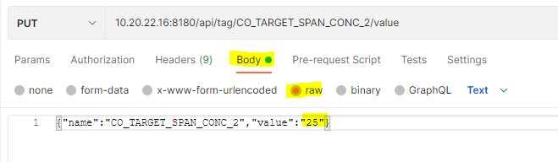

After sending the target concentration change command, we can use the GET function again to verify that the target concentration is now 25.

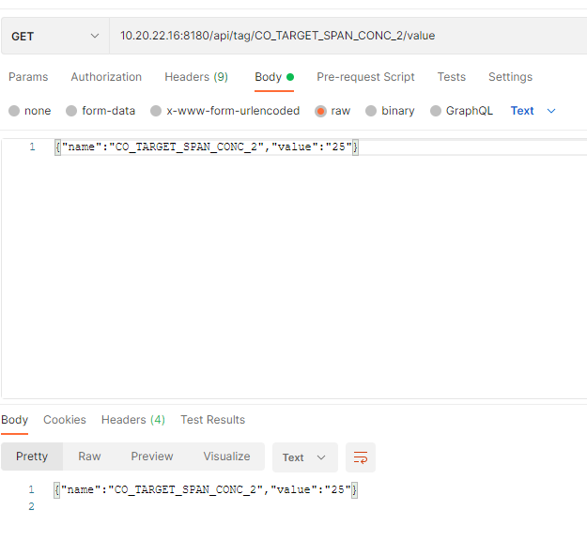

1. PUT A COMMAND TO THE INSTRUMENT

PUT commands can also be used to put the instrument into diagnostic or calibration modes. In the below example, we will check the current instrument mode, and then put the instrument into an auto reference calibration mode.

Example to check the current mode:

<10.20.22.16:8180/api/tag/INSTRUMENT_MODE/value>

Response:

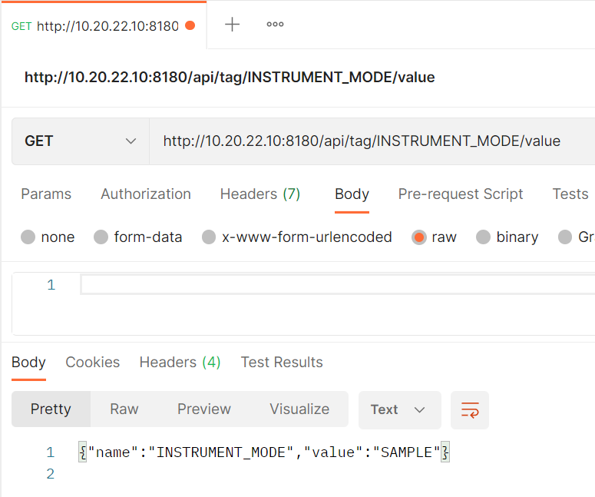

Next we will use a GET command to see the response body for the reset aref var which will trigger the instrument to run an aref if the value is set to true.

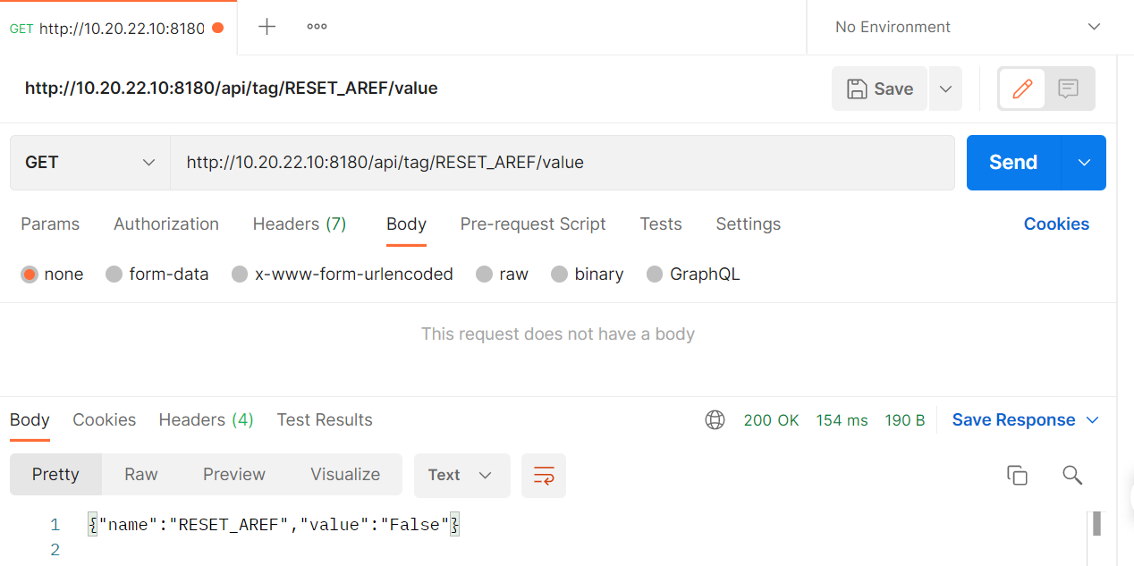

Once we know the body response, we will then PUT the value to “True” which will now put the instrument into an aref mode.

**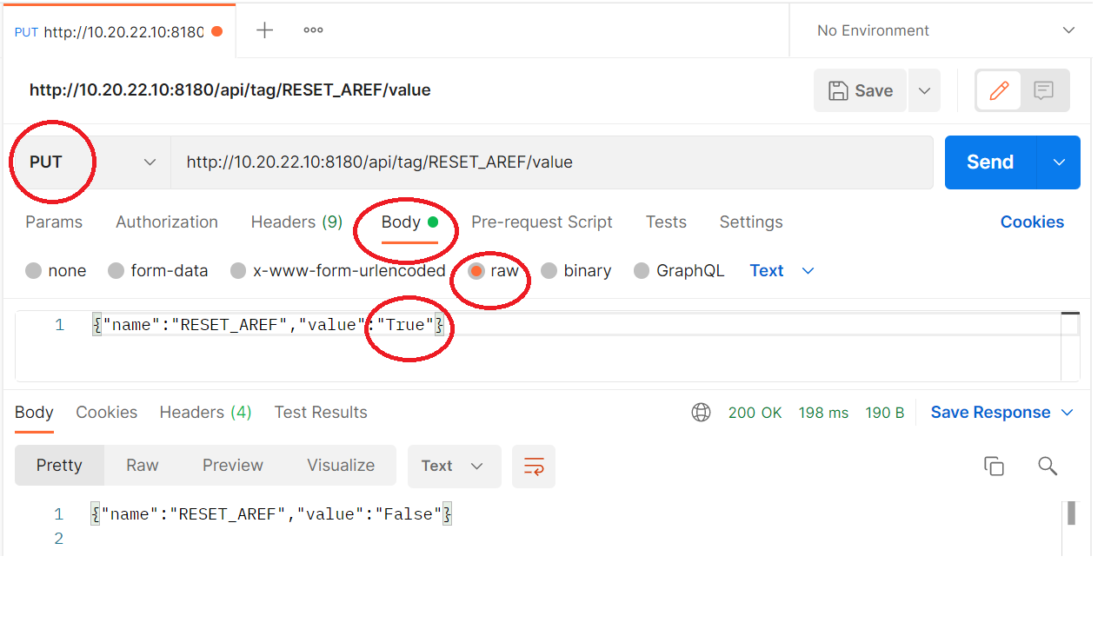**

Lastly, we will use the GET command again to verify the instrument mode is now showing that the instrument mode is in AUTO-REF

