9970 Carroll Canyon Rd, San Diego, CA, 92131

Service Note
Phone (858) 657-9800 Fax: (858) 657-9818 Toll Free 1800 324-5190
E-mail: sda_techsupport@teledyne.com Website: http://www.teledyne-api.com

22-001

31 March, 2022

Troubleshooting TS1 and TS2 Touchscreen issues

- Purpose:

To provide guidance on identifying the source of a touchscreen issue for a TS1 or TS2 display.

- TOOLS:

USB Mouse

- PARTS:

None
- PROCEDURE:

- Plug in a USB mouse to either of the front panel peripheral ports and see if a cursor appears that allows you to control the instrument. If there is no mouse cursor, move to step 2. If there is a mouse cursor, move to step 4.
- Lower the front panel and locate the interface PCA behind the display. See figure 1 for a picture of a TS1 interface PCA with touchscreen controller daughter board.
- Check DS2 from figure 1 part C to see if this is lit or not. If not, re-seat the micro USB connection at J9 from figure 1 part B at the interface PCA, and also at the CPU being careful not to pull on the wires directly. If there is still no light, change the interface PCA.
- If you plug in a USB mouse and get a cursor, see figure 1 part A for the TS1 touchscreen controller. If your interface PCA has this daughter board installed, then you have a TS1 display, and this daughter board itself has failed. If you do not have the daughter board on your interface PCA, then you have a TS2 display, and the display itself has failed.

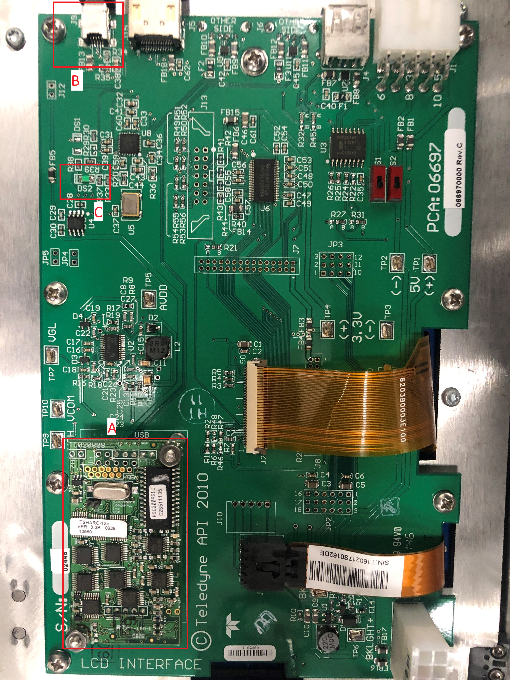

Figure 1

