9970 Carroll Canyon Rd, San Diego, CA, 92131

### Service Note

Phone (858) 657-9800 Fax: (858) 657-9818 Toll Free 1800 324-5190

E-mail: [sda_techsupport@teledyne.com](mailto:sda_techsupport@teledyne.com) Website: <http://www.teledyne-api.com>

***19-002A***

***09 May, 2019***

###### TS1 to ts2 INSTALLATION instructions

1. **Purpose:**

To give instructions on how to install a TS2 display into an instrument that has a TS1 display.

1. **TOOLS:**

# 2 Philips driver

USB wired mouse

1. **PARTS:**

KIT000383 KIT, UPDATE, TS1 TO TS2, DISPLAY

1. **PROCEDURE:**
2. In order to upgrade and install the TS2 display the instrument must have NumaView™ software installed. Please contact [API-Techsupport@teledyne.com](mailto:API-Techsupport@teledyne.com) to ask for the proper NumaView™ for your instrument.
3. If the instrument currently has NumaView™ software you will need to update the software version. Please contact [API-Techsupport@teledyne.com](mailto:API-Techsupport@teledyne.com) and ask for the Full TS2 firmware for the Model Instrument you have.
4. **REMOVAL OF TS1 DISPLAY**
   1. Remove power from the instrument.
   2. Remove the connections to the front panel

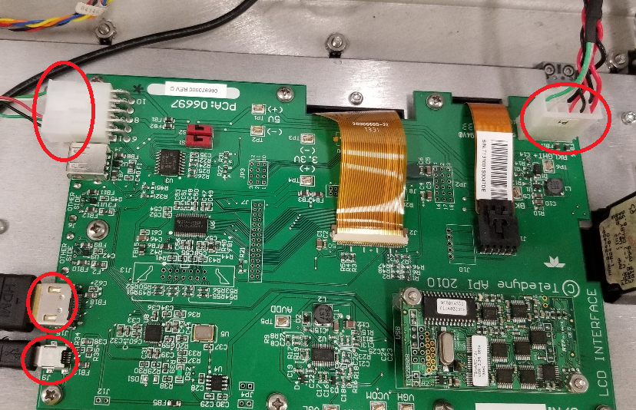

* 1. Remove the 9 screws holding in the PCA board and lift off both the PCA and Display as one assembly. You may need to push from the display side to break it free from the foam.

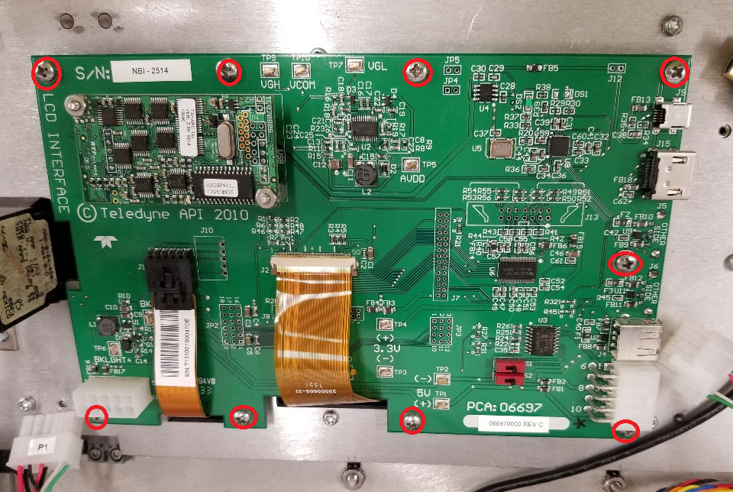

1. **INSTALLATION OF TS2 DISPLAY**.
   1. Install the Grommet Edging to the front panel as shown below. Cut the grommet to fit the edge of panel indicated below.

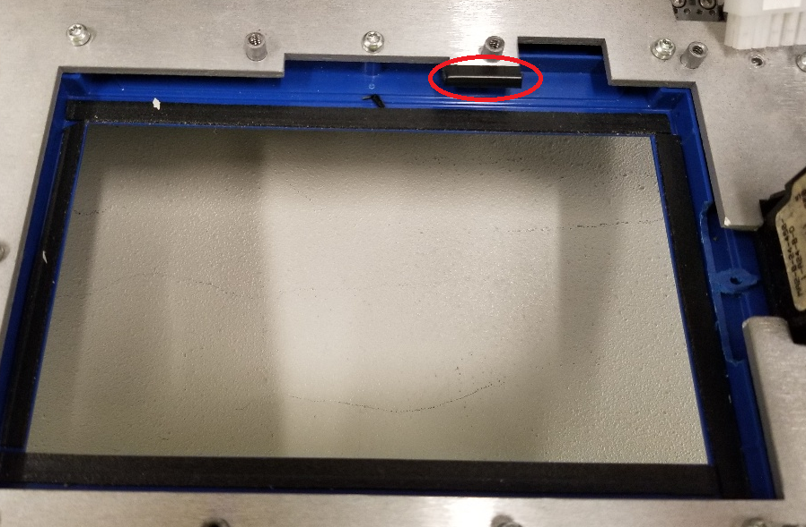

* 1. Center the new Display in the slot then screw down the new PCA with 8 screws.

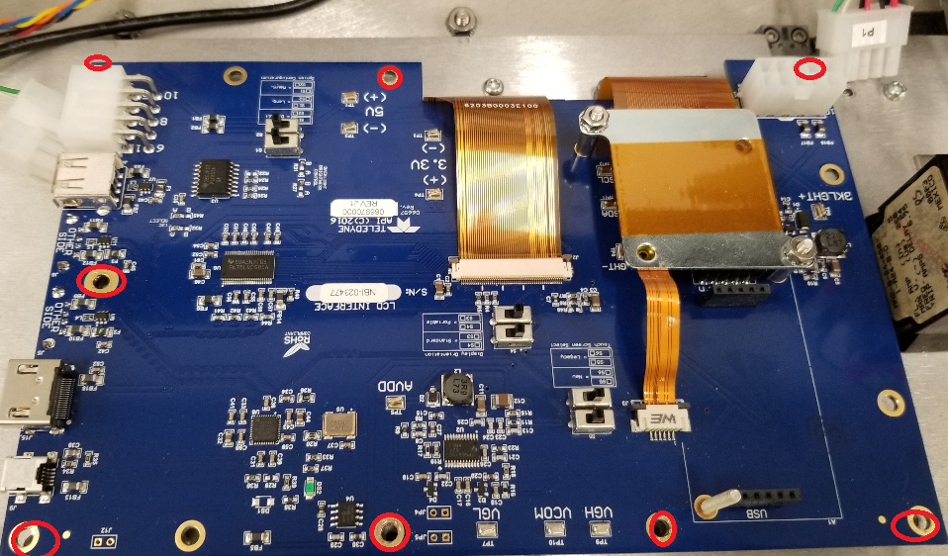

* 1. Reconnect the connections HDMI, USB, Power, I2C

1. Turn on the instrument and let it boot up, insert USB corded mouse in front panel.
2. Install the full TS2 firmware by USB or NumaView Remote.
3. If using USB stick place the 082000000_Txx_x.x.xx.xxx_ts2_full_enc.tapi in the root directory, now plug into the front panel of the instrument and Utilities > USB Utilities then on Update firmware click Check then Install.

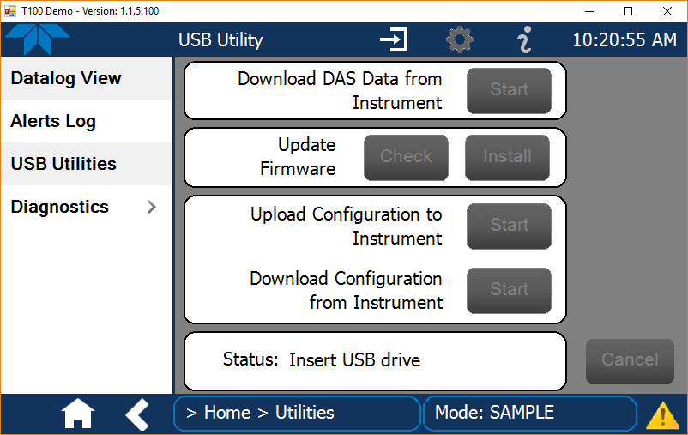

The progress bar will run for about 7 minutes then the time-out error message will appear, as shown below.

- Do not take any action at this point, do not press the close button. Despite the time-out warning, the update process should complete successfully. Full install will take about 17min.

1. If using NumaView™ Remote when you right click the instrument instead of Launch you click Update Firmware and select firmware in the pop-up and then Start Firmware Update.

