9970 Carroll Canyon Rd, San Diego, CA, 92131

### Service Note

Phone (858) 657-9800 Fax: (858) 657-9818 Toll Free 1800 324-5190

E-mail: [sda_techsupport@teledyne.com](mailto:sda_techsupport@teledyne.com) Website: <http://www.teledyne-api.com>

***NOTE19-01***

***03/18/2019***

###### SCI-TURBO TO SCI-552 RETROFIT

1. **Purpose:**

To properly upgrade/integrate from a Sci-Turbo controller to a Sci-552 within an ODS.

1. **TOOLS:**

Philips-head screwdriver

Small Flat-head screwdriver.

1. **PARTS:**

**KIT000382**

***Reuse the following:***

RS-232 cable

EV valves cable(s)

Ozone Sensor cable

1. **PROCEDURE:**
2. Ensure all Power and Gas are de-energized per your facilities Lockout & Tagout procedures before proceeding.

1. The existing SCI-Turbo, P400 cables, Handshake board and Upload cables will need to be removed.
2. To remove the P400 cables the back shell of the 25pin connector on the Interlock board will need to be removed to fit through the P400 connector opening on the rear panel. See photo below.

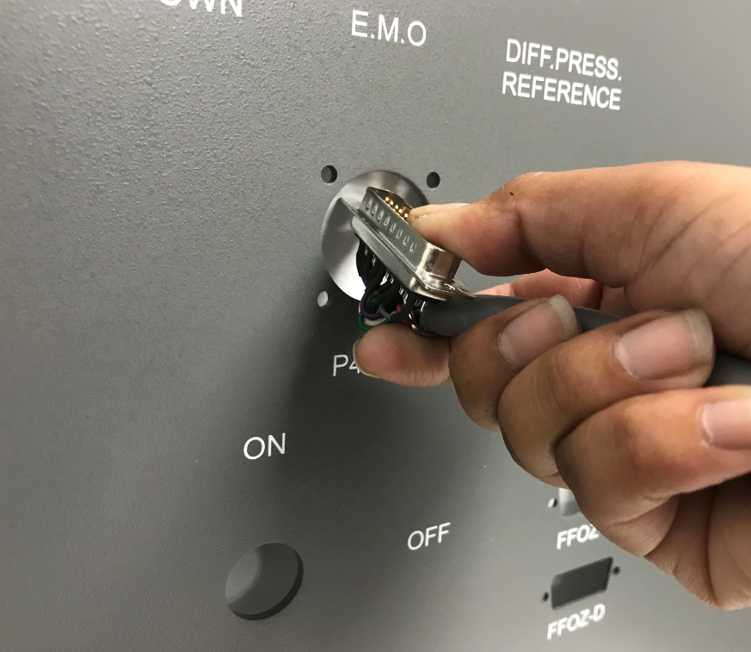

1. The new supplied P400 cables will be installed in the reverse of the removal of the old cables. Be cautious when reinstalling the back shell of the 25 pin connector on the new cable to not pinch any wires.
2. The supplied SCI-552 has a circuit board installed on the rear panel which takes the place of the Handshake board.
3. Route the new P400A & B cables in a similar fashion as the old cables, but the two separate cables of each cable assemble will route to the rear of the interlock board and the SCI-552 respectively.
4. Install the 25 pin connector to the interlock board noting the proper connector location as identified on the cable.
5. Connect the P400A green cable connectors to the rear of the SCI-552. Do note the cable connector’s location matches the tags on the discrete wires.
6. Currently the wires are terminated in a 24+ VDC controlled configuration. When the Generator or EV valve is to be turned on from the customer supplied tool or chamber the signal will be 24+ VDC to enable the component. If the configuration needs to be controlled with a GND signal, please contact [API-TechSupport@Teledyne.com](mailto:API-TechSupport@Teledyne.com) for instructions to change the wiring.
7. After routing the P400B cable in a similar fashion of the P400A cable, install the discrete wires to the proper terminal on the SCI-552 board. See photo below

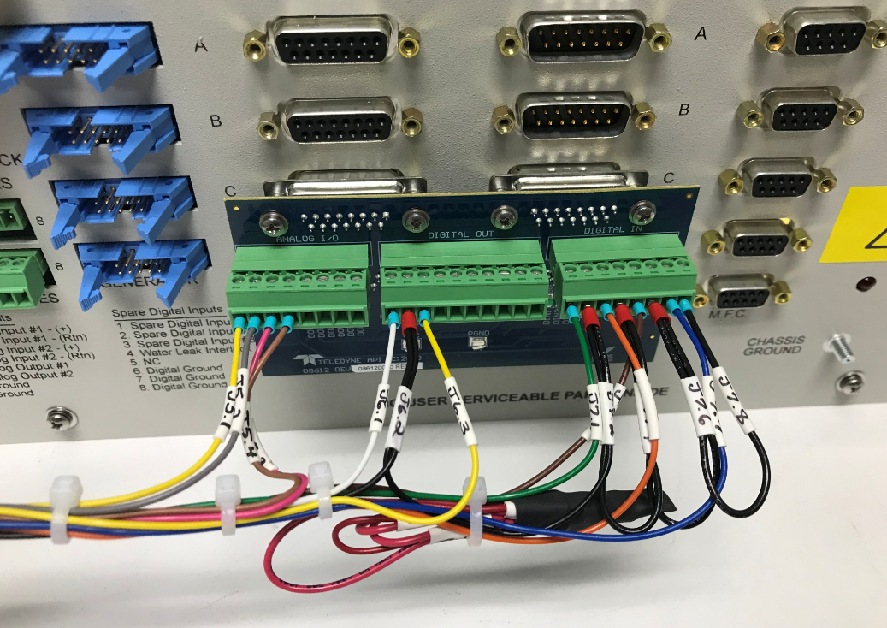

1. Install the upload cable that is supplied to the lower left corner of the Interlock board and to the SCI-552 connector labeled INTERLOCK. See photos below

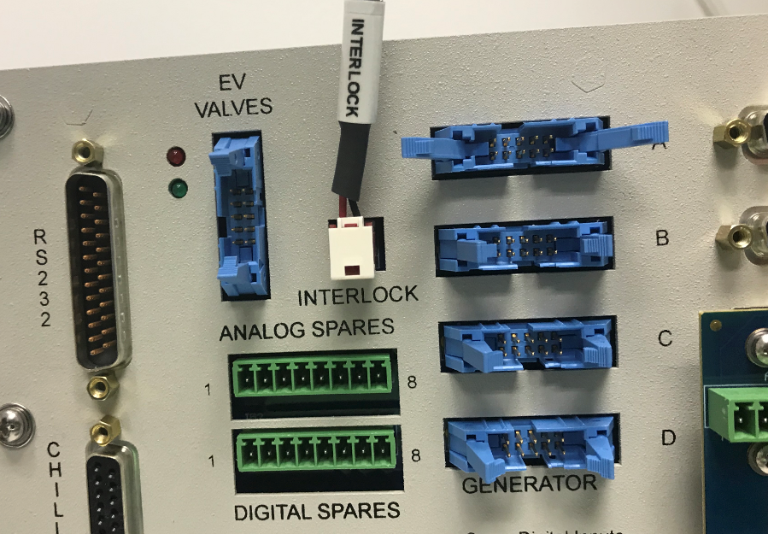 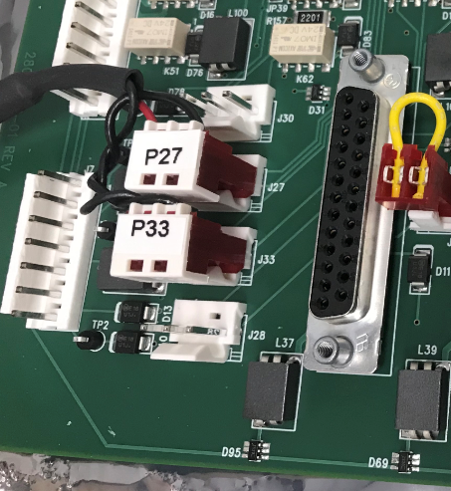

1. Two new Generator cables are included. The longer cable will go to the bottom generator (Generator A) and the shorter cable will go to the top generator (Generator B). Install them both to the proper generator and the proper connector on the SCI-552.
2. The MFC cables will need to be connected to the SCI-552 per the table below

|  |  |  |  |
| --- | --- | --- | --- |
| **SCI-Turbo MFC Connection** | **Description** | **SCI-552 MFC Connection** | **SCI-552 MFC Software Tag** |
| A | Paired O2 & N2 MFC for Ch. A | A | Ch. A O2 |
| B | Paired O2 & N2 MFC for Ch. B | B | Ch. B O2 |
| C | O3 MFC for Ch. A | N2 | Ch. A N2 |
| D | O3 MFC for Ch. B | D | Ch. B N2 |

1. Reinstall the remaining cables—RS-332, EV Valves and Ozone Sensor to their respective connectors.
2. After all cabling connections are completed, route cables away from moving components, sharp edges and hot surfaces. Use the included plastic wire ties to bundle cables together.
3. Reenergize the equipment and check for proper operation.