9970 Carroll Canyon Rd, San Diego, CA, 92131

Service Note
Phone (858) 657-9800 Fax: (858) 657-9818 Toll Free 1800 324-5190
E-mail: sda_techsupport@teledyne.com Website: http://www.teledyne-api.com

Note 19-001A

05/01/2019

MAKING THE TOP CHASSIS COVER EASIER TO INSTALL

- Purpose:
We understand that the top covers of our instrument chassis may at times be difficult to install or uninstall. We believe it is due to shipment where the front bezel of the unit has been inadvertently displaced.

- TOOLS:
#2 Phillips screwdriver
¼” hex wrench

- PARTS:
None

- PROCEDURE:

- Installation of the top chassis cover is affected by the alignment of the fasteners locations on the top and bottom of the chassis and also due to the front bezel location. We have found that if the bezel is allowed to “float” while the fasteners are installed on the chassis, the covers can be easily opened or closed.
- Except for zero air generators, the bezel is installed to the bottom of the chassis by several bolts. The most important bolts for aligning the cover are the ¼” nuts on the inside of the bezel on the right- and left-hand sides. Please see figures 1 and 2 below. Loosen these nuts to allow the bezel to “float”.
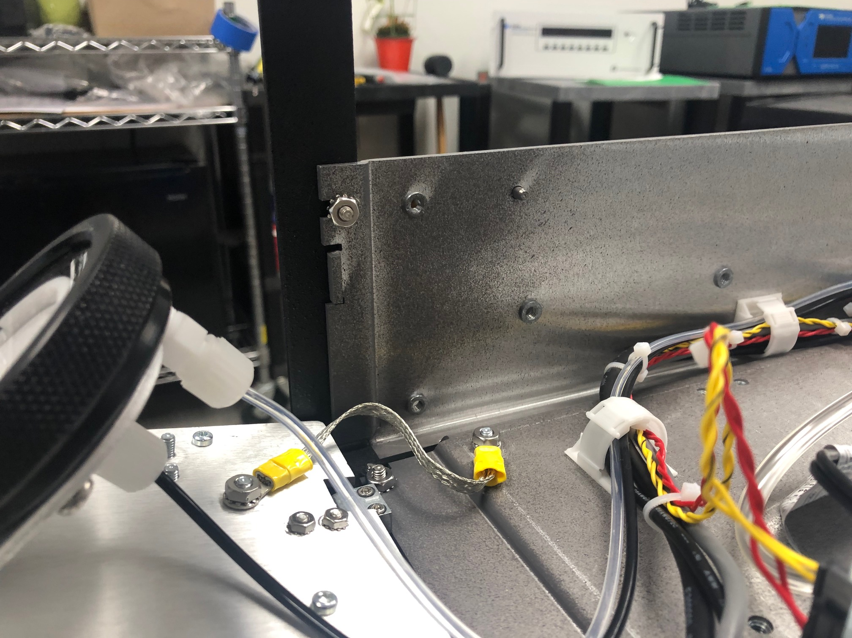 | 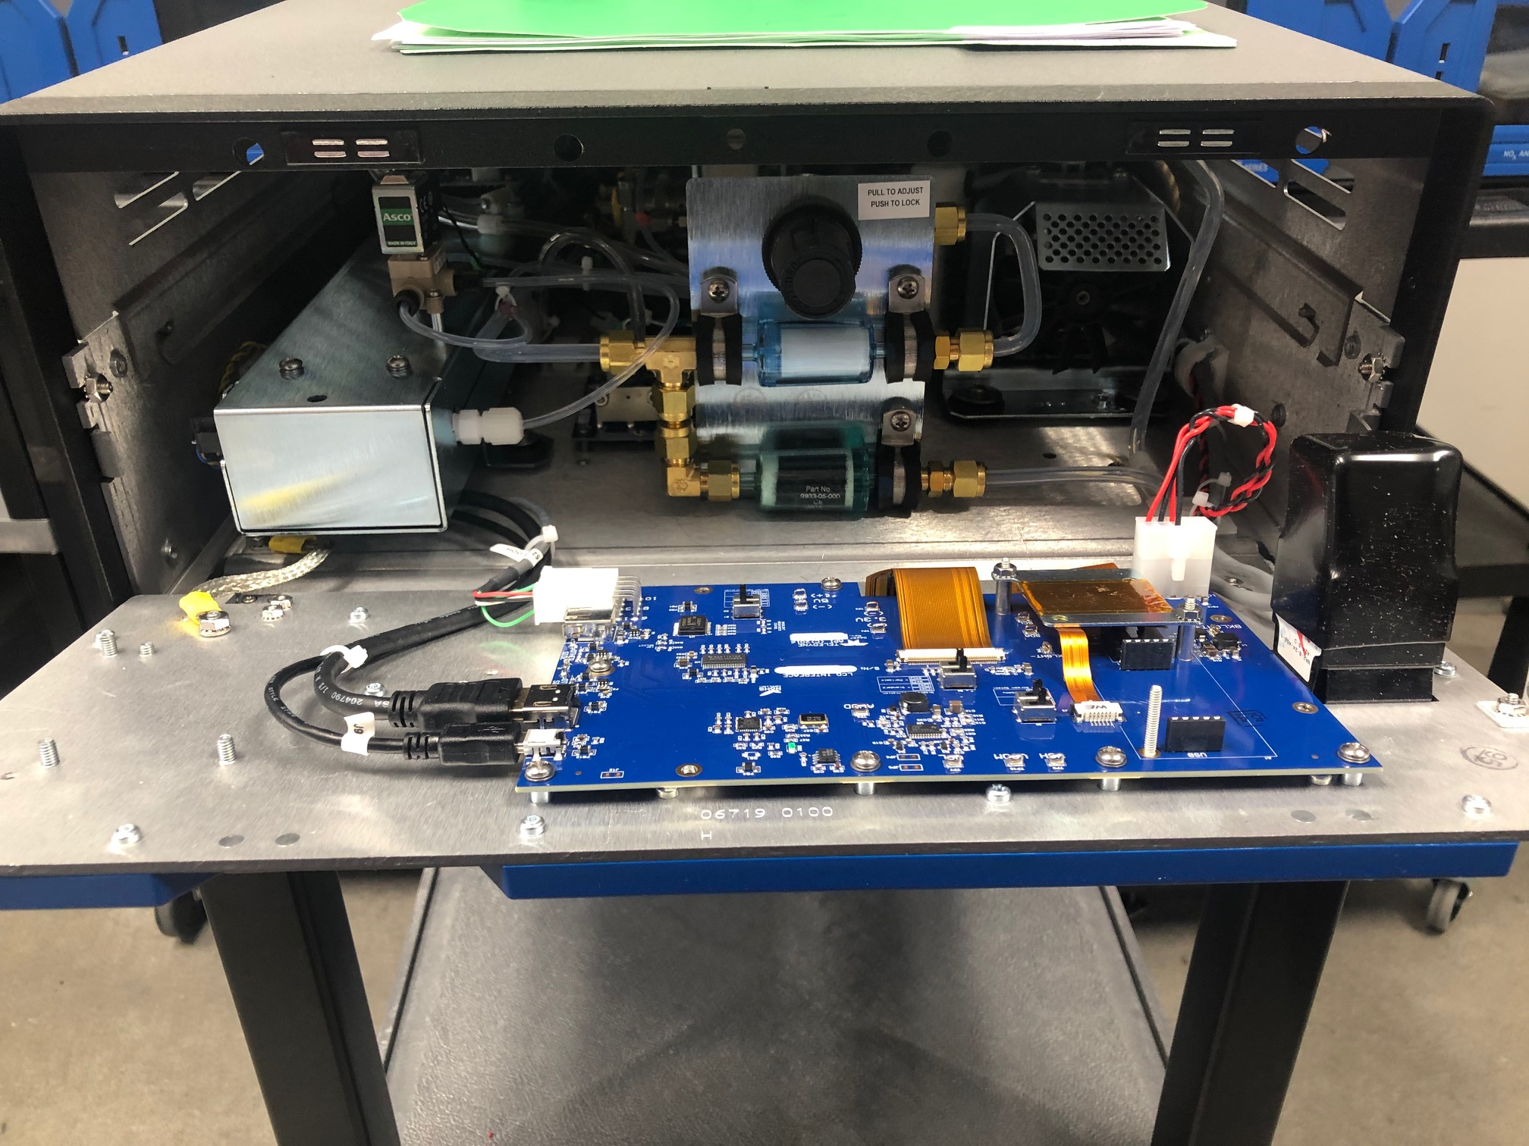
Figure 1 | Figure 2

- On zero air generators, the bezel fasteners are two Phillips head bolts located externally on the center of each side of the bezel. See figure 3 below:
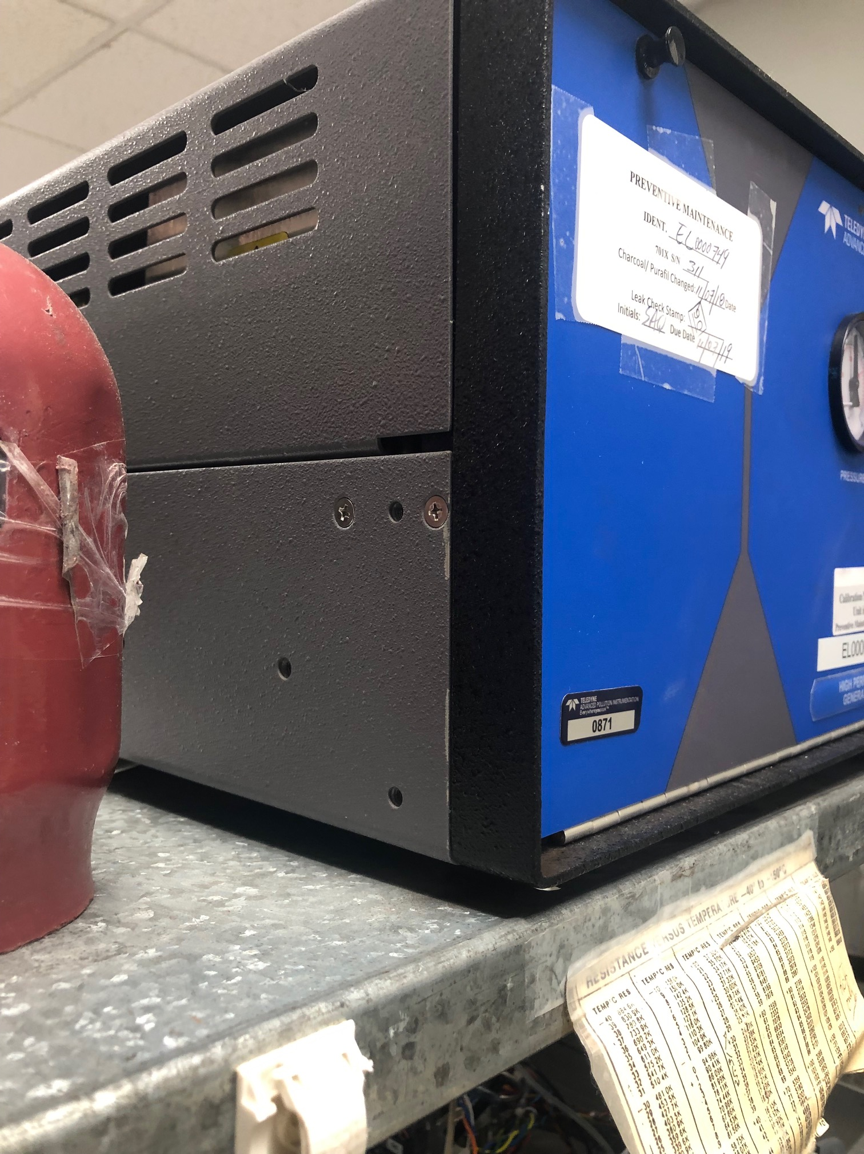
Figure 3

- With the bezel “floating”, install the cover onto the bottom of the chassis. You’ll note that the cover can be fastened smoothly to the bottom with a #2 Phillips screwdriver.
- When the chassis fasteners are snug, you now can tighten the bezel nuts. If you need to align the bezel to the cover, you’ll be able to tap the bezel to do this.
- In rare cases, you may need to loosen the bezel fasteners located on the bottom of the chassis. This may allow a greater degree of float, but we find that this additional action is not normally needed. As above, be sure to refasten the fasteners when the cover is installed.

If you have any questions, please contact Teledyne API directly (+1 858.657.9800 ph;) (sda_techsupport@teledyne.com), your local Teledyne API distributor, or Teledyne API Regional Sales Manager for support.

