**Clearing Analyzer Fault from Power Down/Power Loss**

1. On the Homescreen of the analyzer select “Setup”

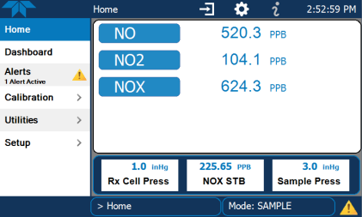

1. On the Setup menu you will see several options listed to you select “Digital Outputs”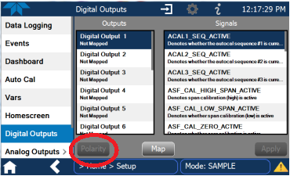
2. In the Outputs section of the screen select Digital Output 1. You will see the “Polarity” button (Circled in Red) become selectable, click on Polarity then click Apply. This will change the polarity into a negative state. Reverse the polarity again switching it back into a positive state, (Polarity > Apply). This will clear out the fault.