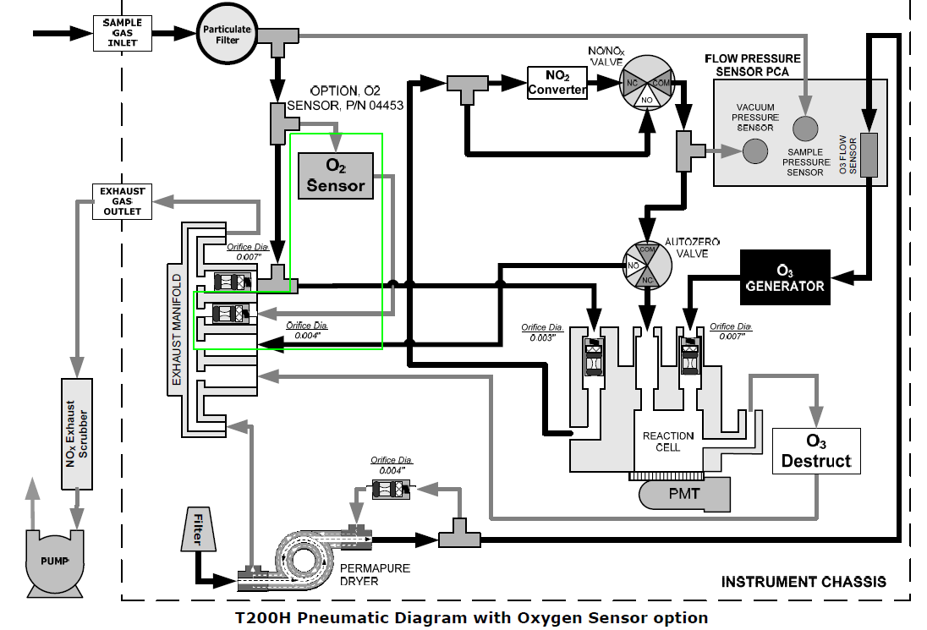

Information contained herein is classified as EAR99 under the U.S. Export Administration Regulations. Export, reexport or diversion contrary to U.S. law is prohibited.