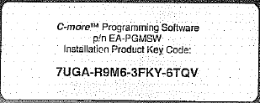
7UGA-R9M6-3FKY-6TQV

